OFFENDERS RELATED TO THE VICTIM:

1)

SELECT Area_Name,

sum(No_of_Cases_in_which_offenders_were_Neighbours) as Neighbours

FROM "21_Offenders_known_to_the_victim"

GROUP BY Area_Name

ORDER BY Neighbours DESC

CONCLUSION: Madhya Pradesh is the highest number of offenders related to the rape victim.

Lakshadweep is the lowest number of offenders related to the rape victim.

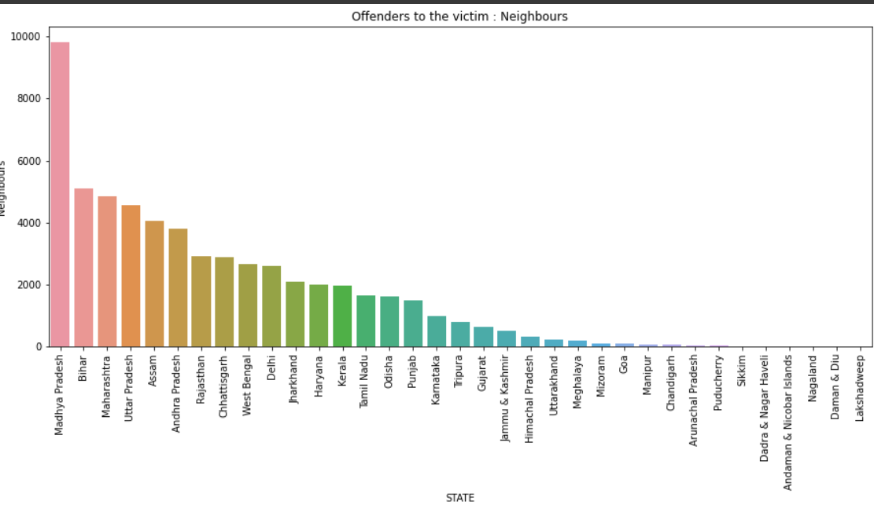

2)

SELECT Area_Name,

sum(No_of_Cases_in_which_offenders_were_Other_Known_persons) as Other_Known_Persons

FROM "21_Offenders_known_to_the_victim"

GROUP BY Area_Name

ORDER BY Other_Known_Persons DESC

CONCLUSION: Madhya Pradesh is the highest number of Offenders related to the rape victim. Lakshadweep is the lowest number of offenders related to the rape victim.

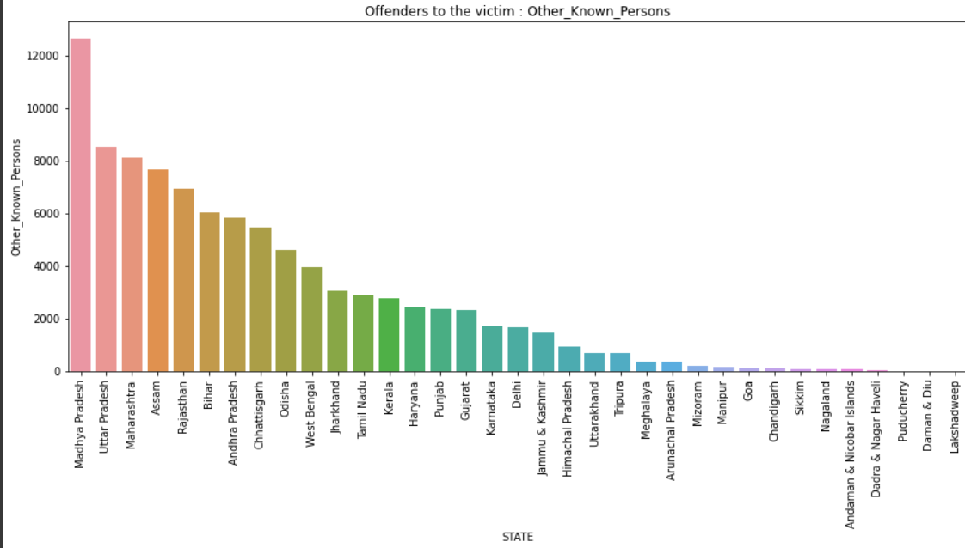

3)

SELECT Area_Name,

sum(No_of_Cases_in_which_offenders_were_Parentsclose_family_members) as Parents_Close_Family_Members

FROM "21_Offenders_known_to_the_victim"

GROUP BY Area_Name

ORDER BY Parents_Close_Family_Members DESC;

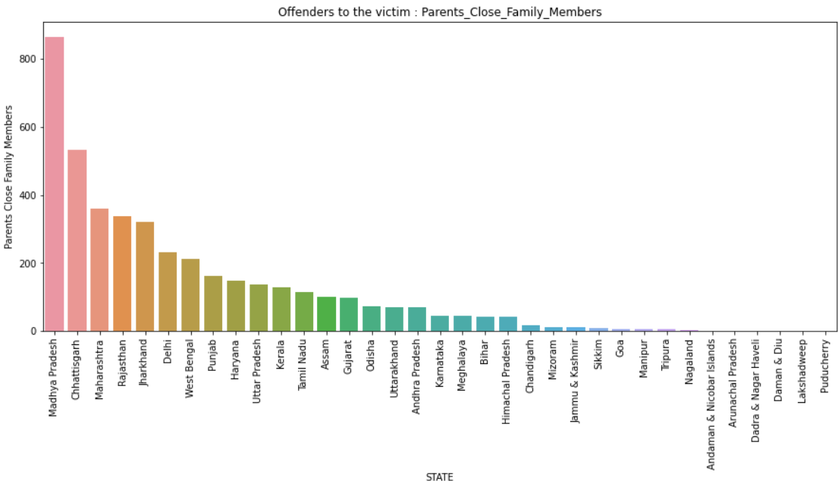

CONCLUSION: Madhya Pradesh is the highest offenders related to the victim. Puducherry is the lowest offenders related to the victim.

4)

SELECT Area_Name,

sum(No_of_Cases_in_which_offenders_were_Relatives) as Relatives

FROM "21_Offenders_known_to_the_victim"

GROUP BY Area_Name

ORDER BY Relatives DESC

CONCLUSION: Madhya Pradesh is the highest offenders related to the victim. Nagaland is the lowest offenders related to the victim.

